**Running the Hippocampal BMTK Model on NSG with Sim Agent**

In order to prepare for running big networks in a reasonable amount of time, it is necessary to take advantage of supercomputing resources such as NSG to speed up the runtime of large networks. This guide will take you through how to use Sim Agent to run experiments using the Hippocampus-bmtk model.

**Installing Sim Agent and the Hippocampus-bmtk model**

The first step is to install Sim Agent. This is a tool developed by Tyler Banks to simplify interfacing with supercomputing resources such as NSG and Lewis. It can be downloaded from: <https://tylerbanks.net/SimAgentMPI/>

The files used in this example can be downloaded from <https://github.com/tjbanks/hippocampus-bmtk.git>

Look for the Sim Agent installer and allow access to install on your machine. Run the setup wizard and allow Sim Agent to install on your computer.

Either download a zip file of the hippocampus network code or clone the above Github repository to gain access to the required network files.

**Running a basic seed sweep on NSG**

There are three main steps to run the Hippocampus simulation, the legacy directory needs to be created (if it doesn’t exist already), the mod-files must be compiled, and the simulation itself needs to run with a random seed.

**Creating the legacy directory and setting up the model to be run on NSG:**

1. Navigate to your Hippocampus-bmtk directory, then navigate to the Guntu-Banks folder and create a new directory called legacy
2. The next step requires writing a run script, which will be used as the entry point to run the simulation on NSG.
3. Create a file called run.py and copy the following contents into the file:



This is will first compile all the required mod files locally on the NSG servers then run experiment 0 with random seed 9000 and parameters from simulation_config.py.

**Running the simulation on the NSG servers with Sim Agent:**

Now that we have prepared the network by creating the required directories and creating the simulation entry point, we need to run the job on the NSG servers. The first step is to set up a connection to NSG from within Sim Agent.

1. From within sim agent go to Servers > Add Server, then under the Display Name field, enter an appropriate name for the job you want to run.
2. Go to <https://nsgr.sdsc.edu:8443/restusers/login.action> and log in with your NSG account information, go to the developer dropdown and select application management. 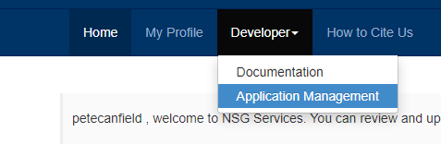
3. Select Create new application, give it an appropriate name (I used Sim_Agent), write a description, Select Authentication Type as DIRECT and create the application. 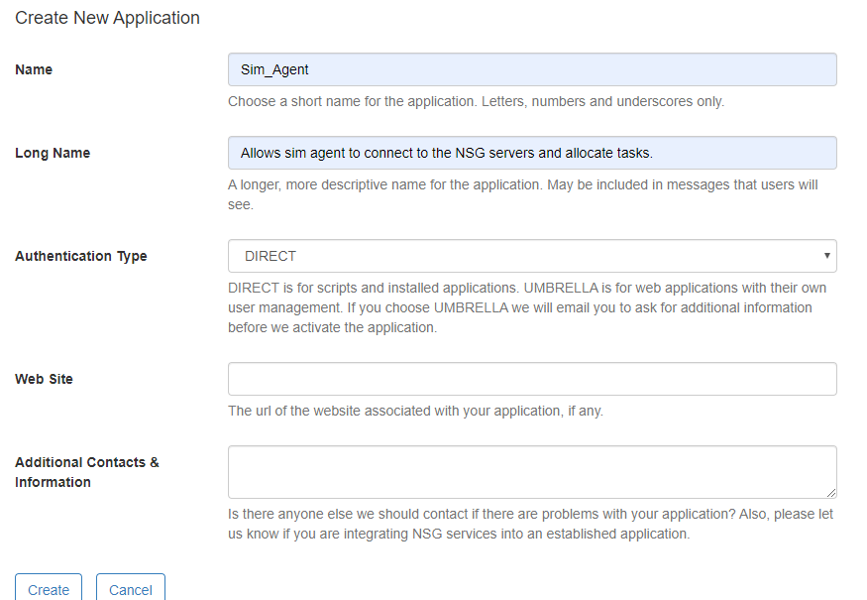
4. Copy down the application Name and ID then move back to the Sim Agent server entry box and enter the information in the required fields.

Now that Sim Agent has an established connection with NSG, we can create a new job to be run on the NSG servers.

1. Click on Select Directory within Sim Agent and navigate to your GuntuBanks-bmtk directory which we have already prepared.
2. Next, click New Job in Sim Agent and name it something which is meaningful to you, in the Server Connection drop down, select the connect which you created in the previous steps. 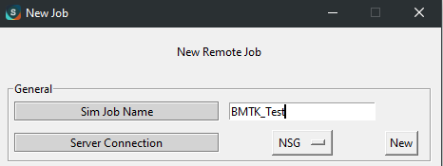
3. For Tool select PY_TG_3.5.0 and for main run file select the run.py file which we created earlier
4. Next select the desired compute resources, for this task I will use 16 cores and 1 node. Check the Uses python check box and review other options. 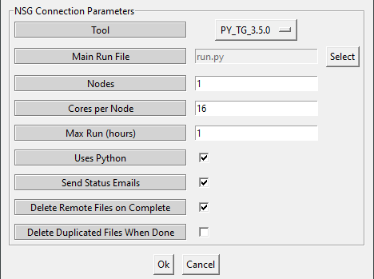
5. Click Okay and run your simulation! If the job has semeted correctly the log file display ”NSG template validation success”